TITLE:USERNAME AND THE PASSWORD SNIFFING ATTACK BY USING WIRESHARK TOOL.

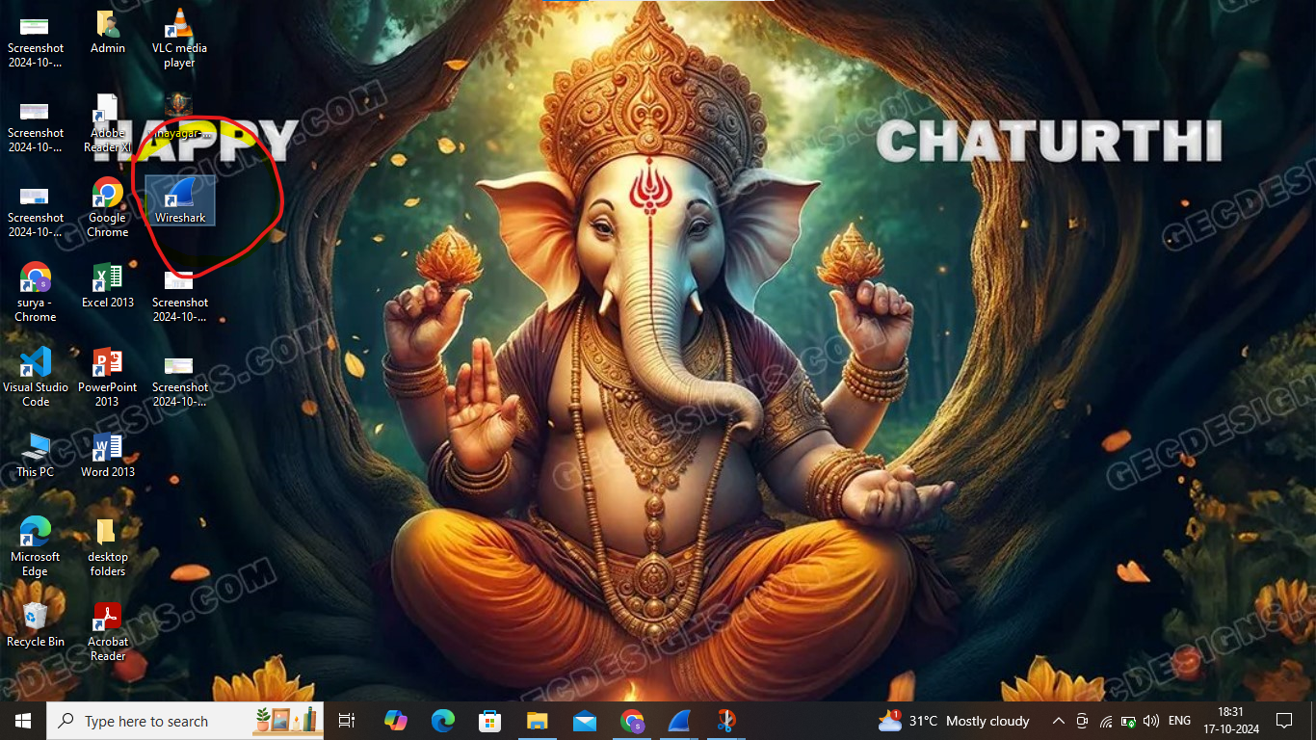

First you want to download the wireshark from the official website for the username and the password sniffing .Next open the wireshark tool with the administrator privaliges.

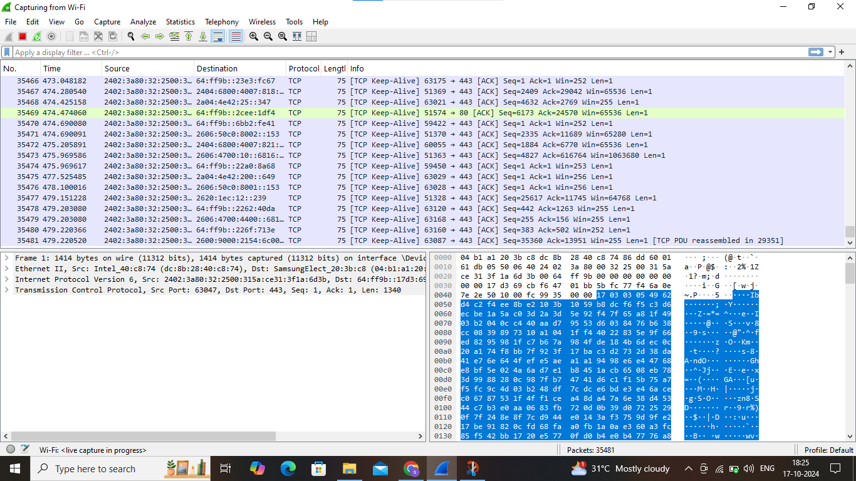

Then choose the interface which the system is connected to internet then it will capture all the network packets.After that leave it for some times.

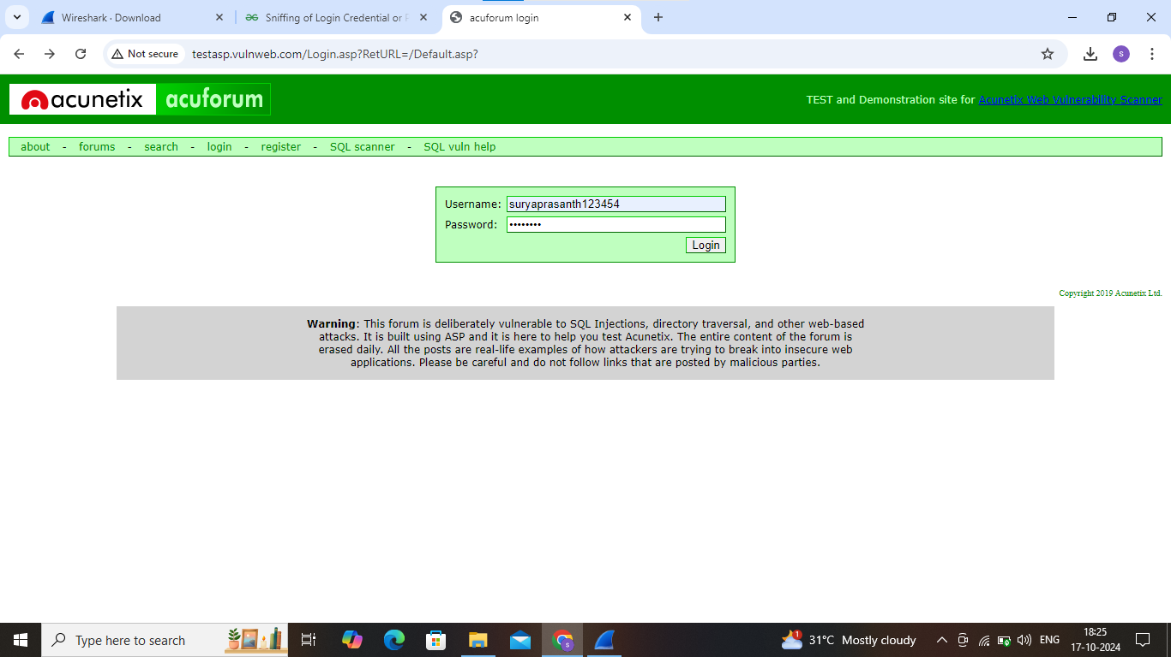

Open the Insecure web application called Acentux vulnerable web.com for the testing and give any username and the password .

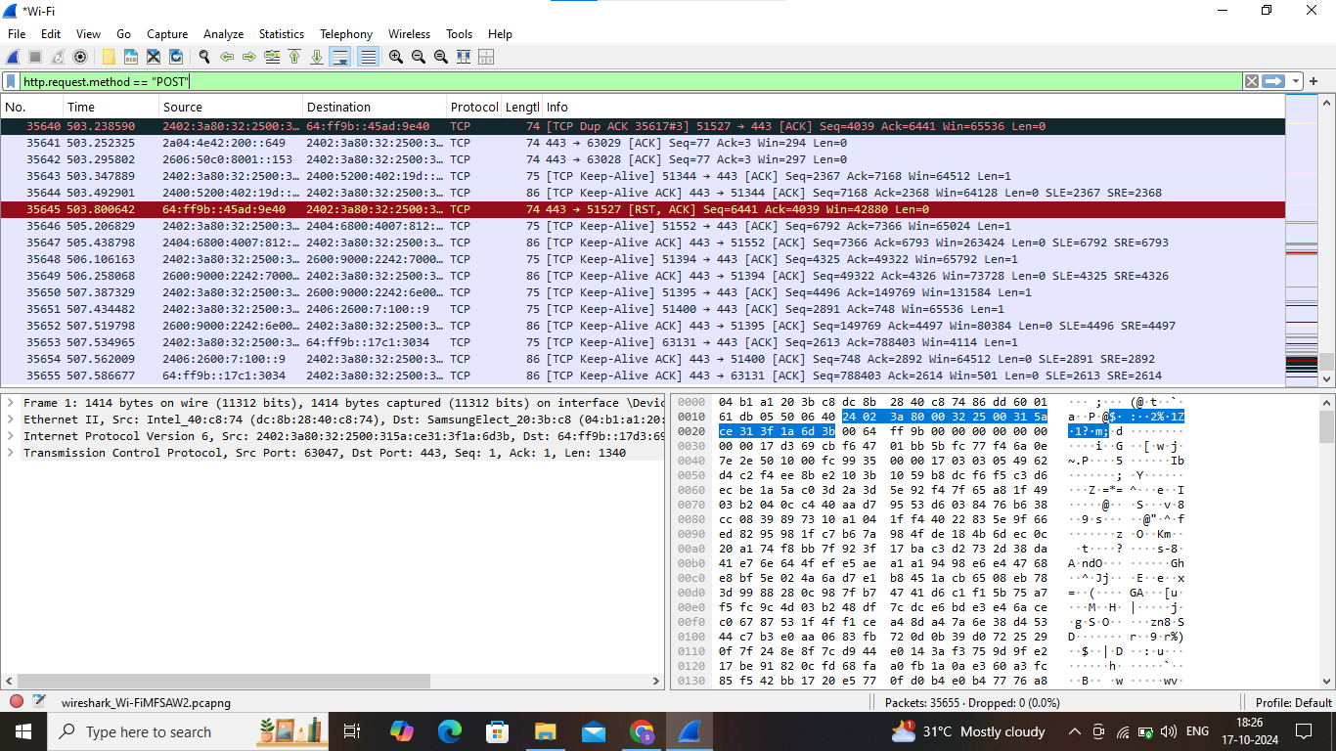

Then in the top of the wireshark application type “http .request.method == POST”This will shows the packets with the POST informations.

a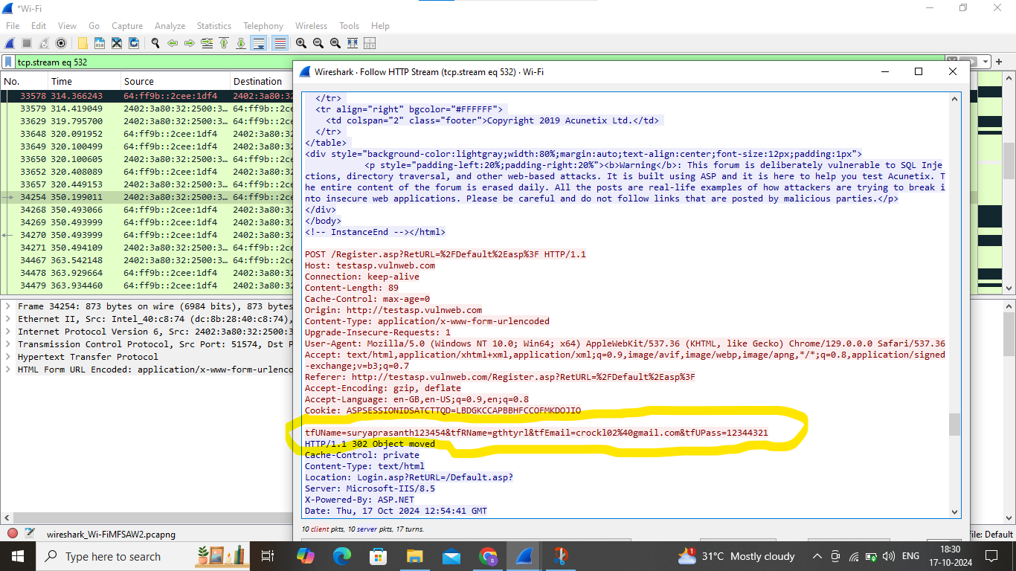

After that we want to choose the post option packet right click and choose the follow and http stream.Then we will easily see the username and password where the user entered in the vulnerable website.It is done by insecure connection.

Solution:check the website connection whether its running on the http or https. So ensure https is secure option.if we use the insecure connection then it will be very easy for the attackers to sniff your username and the password.